|  |
| --- |
| **INFO8231 Assignment 1 Section 03 Team 03**  *By signing below, I certify that I have fully complied with the INFO8230 Code of Honor.*  Student 1: Harit Thoriya  Student 2: Pankaj Valani  Student 3: Kishan Bhalani  Student 4: Ramandeep Singh  Student 5: Heet Raval |

**INFO8231**

**Team Assignment 1**

**Task 1: ITCPA Agile Project Charter**

1. **System Objectives**

* Conestoga College ACSIT requires an added information system to replace the manual capstone project submission and approval process.
* The ITCPA project aims to resolve any inefficiencies and streamline the end-to-end capstone project approval process and automate end-to-end: from the client project proposal and student team request, up to the student team project application approval, using the features of a modern cloud-based technical architecture.
* The ITCPA application will be built using the SAP Fiori design guidelines. Using a full development cycle that includes local development environment using VS Code and MySQL, a staging environment, and a production environment on Azure cloud platform.
* The new system must continue to support the following major user roles: Faculty Advisors, IT Program Coordinator, Students and Clients.
* The new system must provide an extensive set of reports and that can be viewed and printed. ￼

1. **Project Roles/Responsibilities**

**Client Staff**

* **Lea Armstrong**, IT Program Coordinator: Project Sponsor, responsible for approving the project initially and then approving deliverables as the project proceeds;
* **Ted Tanner**, ACSIT Faculty Advisor: Project Contact / Domain Expert, responsible for working with the Technical Staff to manage the project on a day-to-day basis; also responsible for providing information and answering questions.

**Technical Staff**

* **Harit Thoriya**, Senior Software Developer: Scrum Master, responsible for facilitating scrum meetings and activities; removes obstacles of the Development team members;
* **Kishan Bhalani**, Business Analyst / QA: Product Owner, responsible for prioritizing the product backlog, business analysis and software testing;
* **Pankaj Valani**, Senior Software Developer: Development Team Member, responsible for developing the back-end services (API) of the system;
* **Heet Raval**, Front-end Software Developer: Development Team Member, responsible for developing the UI of the system;
* **Ramandeep Singh**, Front-end Software Developer: Development Team Member, responsible for developing the UI of the system.

1. **Business Benefits**

* The new **External Client Proposal** Subsystem will provide efficiency so that,
  + Quickly and reliably get the student team for project proposal.
  + New system will provide updated project proposal information of potential clients to student if there are any changes in requirements without any disruption to faculty advisor.
* The new **Capstone Project Matching** Subsystem will help so that,
  + Faculty Advisor to quick match project to student. So that, they can save the time and focus on main job as teaching professor.
  + Streamline and efficient automation system will reduce the workload of IT coordinator which will lead to substantial time and cost savings for Conestoga College.
* The new **Student Team Management** Subsystem will improve:
  + Time and effort of the student will be reduced for getting project proposal from client.
  + Faculty and client access to student team status updates, including submission progress and project milestones which significantly reduce the effort of client and faculty.

1. **Requirements**

**4A. Preliminary Functional Requirements**

**User Story 1: As a Student, I want to know the client project proposal details, so that I can select the right proposal for a capstone project.**

* **Preliminary Acceptance Criteria:** 
  + Able to see the status of all client proposal.
  + Filter the client proposal based on the status.
  + Able to see the scope and the requirement of the proposal.
  + Able to see the detail of the client such as email.
  + Able to send an email to the client to express interest.

**User Story 2: As a faculty advisor, I want to assign an approved project to my student team, so that, my team can get notified and start working on the project.**

* **Preliminary Acceptance Criteria:** 
  + Able to find the approve project.
  + Able to find the student team.
  + Assign the project to the student team.
  + Project status should change to taken.
  + Assigned team should be notified.

**4B. Non-functional Requirements**

|  |  |
| --- | --- |
| **Usability requirements** | * Should be able to search student team with one of student name. * Should be able to see status of the project all the time. |
| **Reliability requirements** | * System should be always available. * There should be disaster recovery plan should be emplaced. |
| **Performance requirements** | * System should not take too much time to response the any request. * System should not be low or unresponsive due to high user load. |
| **Security requirements** | * System should be accessible by Conestoga community only. * System should use latest encryption method so that, clients project information will be confidential. |

1. **Project Team Critical Success Factors**

* The ITCPA stakeholders are Client, IT Program Coordinator, Faculty Advisors and Student.
* The Product Owner should provide project feature wise value and help. So that most use full functionality base created before development start product.
* The Scrum Master should: provide excellent communication and collaboration with team and remake incoming difficulty and ensure this process follow proper way.
* Team members should participate in all meetings and follow good code standard and make testing steps and before deadline provide effective quality of project.

1. **Preliminary Technical Architecture:**

**The proposed technical architecture is the proposed technical architecture is a modern based application.**

* 1. **Development environment**
* Framework: Node.js, front-end & back end.
* Database: SQL, Mongo DB for store user data.
  1. **Production Server Environment**
* Web Server: Apache HTTP Server, XAMPP, LiteSpeed Web Server and Nginx for serving the web application.
* Application Server: Need to Play console for android application and Appstore for IOS application and firebase in upload application.
* Database Server: Microsoft SQL Server, MySQL, PostgreSQL this all manage the production database.
  1. **Production Client Environment**
* Client Device: Support mobile app all version in client device and Web app time browsers support (Mozilla, Firefox, Chrom etc.)
* Security: Must be implement HTTPS using SSL/TLS certificates to secure user data because this format in not possible to encrypt data.
* Hosting: Once project done then host project to production environment cloud. Use some cloud like AWS (Amazon Web Services) server etc.

**Task 2: Proposed To-be Workflow**

**Business Process Name:** Capstone Project Approval Workflow

**Process Goal:** To make automate end to end capstone project approval process. Assuring effectiveness and transparency for all stakeholders.

**Process Result:** The successful approval & allocated project to team and improve visibility and reduce manually process.

**Workflow Diagram:**

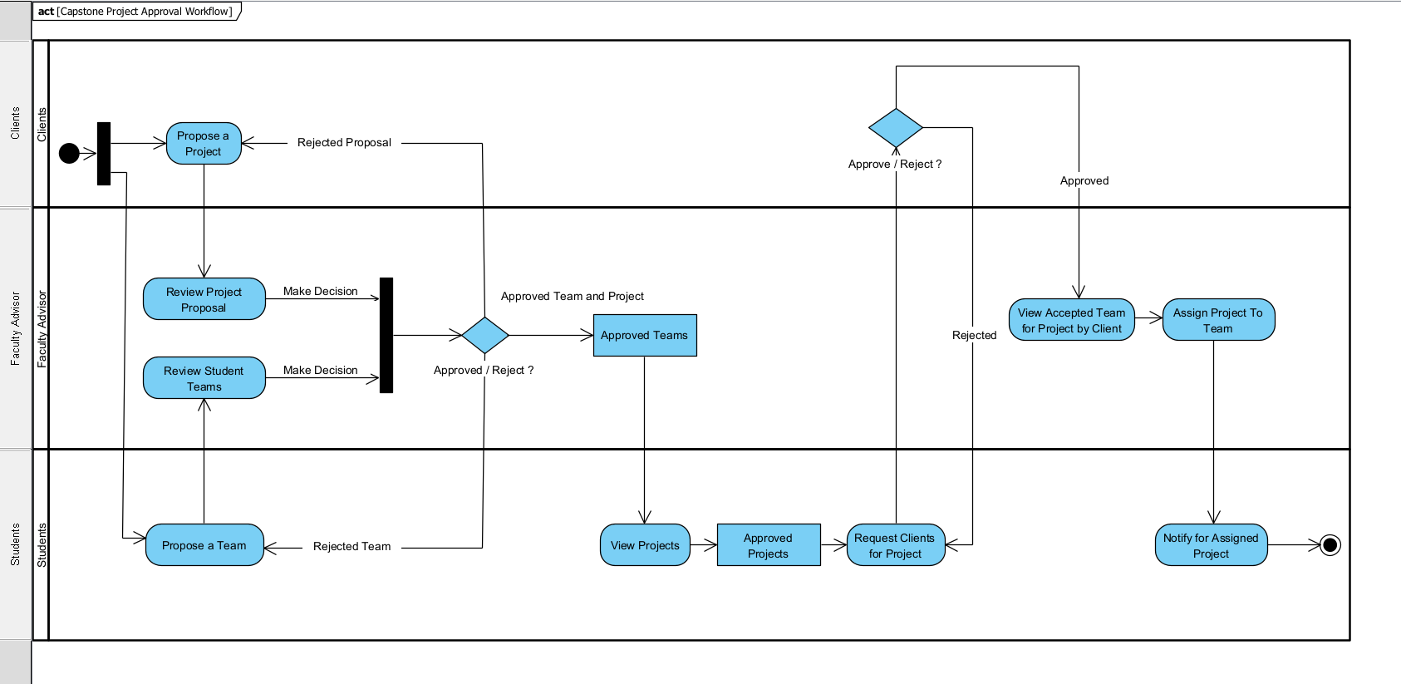

**Appendix A: Interview questions for the stakeholders**

**1. Stakeholder 1 Name / Position: IT Program Coordinator**

**Questions:**

* **Close-ended question:** Have you face any difficulty and challenges with current manually project approval process?
* **Open-ended question:** Can you give any examples of situations where the manual procedure frustrated or inefficiently served the students or the faculty?

**2. Stakeholder 2 Name / Position: Faculty Advisor**

**Questions:**

* **Close-ended question:** Does manually assigning student teams to client projects each term take a lot of your time?
* **Open-ended question:** How do you see faculty advisors and students managing client projects benefiting from the automation of the capstone project approval process?